1.Create a comparison table listing at least 4 key differences between RADIUS and TACACS+ features, focusing on protocol type, encryption, ports used, and command authorization.
Feature | RADIUS | TACACS+
1. Protocol Type | Uses UDP protocol. | Uses TCP protocol.
2. Encryption | Encrypts mainly the user password; other information is generally not encrypted. | Encrypts the entire packet payload, providing better protection for authentication data.
3. Ports Used | UDP 1812 for authentication and UDP 1813 for accounting. | TCP 49 for authentication, authorization, and accounting.
4. Command Authorization | Provides limited authorization and generally does not provide detailed per-command authorization. | Supports detailed command-by-command authorization, especially useful for network device administration.
5. AAA Functions | Authentication and authorization are combined, while accounting is separate. | Authentication, authorization, and accounting are separated.
6. Common Use | Commonly used for Wi-Fi, VPN, and network access authentication. | Commonly used for Cisco/network device administrator access.

2.Draw a simple flowchart or sequence diagram that illustrates the RADIUS authentication process for a user trying to log in to a Wi-Fi network (like at a coffee shop or college campus).
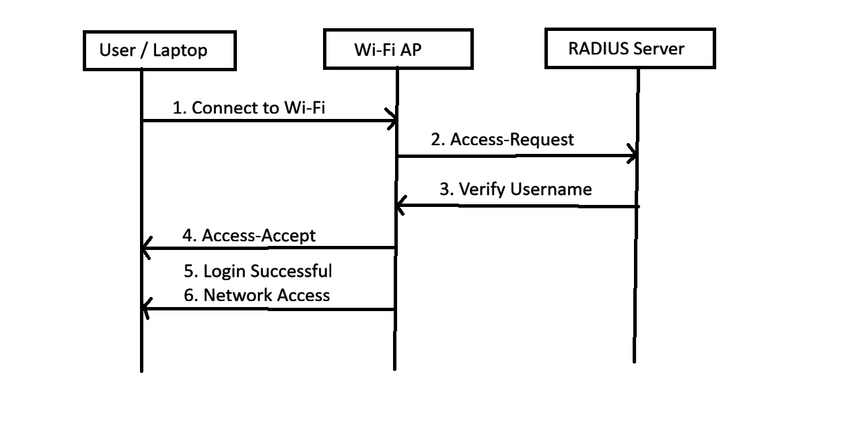
- User connects to Wi-Fi – The student enters username and password.
- Wi-Fi AP sends Access-Request – The Access Point forwards the authentication request to the RADIUS server.
- RADIUS verifies credentials – The RADIUS server checks the username/password.
- Access-Accept – If credentials are correct, RADIUS sends approval to the Wi-Fi AP.
- Login successful – The AP allows the user to connect.
- Network access granted – The user can access the college/coffee-shop network.
3.Describe a real-world scenario from any app you use (such as Zomato, Paytm, or IRCTC) where TACACS+ would be more suitable than RADIUS for managing admin access, and explain why.
Real-World Scenario – TACACS+ for Zomato
Consider a company like Zomato that has many servers, routers, switches, and firewalls. Network administrators need to log in to these devices to configure and manage the network.
In this situation, TACACS+ would be more suitable than RADIUS for managing administrator access.
Why?
- TACACS+ separates authentication, authorization, and accounting (AAA).
- It can provide command-level authorization, so an administrator can be allowed to run some commands while being restricted from running sensitive commands.
- It encrypts the entire TACACS+ packet payload, providing better protection for administrative communication.
- It provides detailed accounting/logging, making it easier to track which administrator performed which action.
Example:
A Zomato network administrator may be allowed to view network configurations but not change firewall rules. TACACS+ can control this at the command level.

4.List two advantages and two disadvantages of using RADIUS for network authentication in a public hotspot (like those found in malls or airports).
Advantages:
- Centralized Authentication: RADIUS allows the hotspot to manage user authentication from a central server instead of storing user credentials on every access point.
- Scalable: It can handle a large number of users, making it suitable for public Wi-Fi in malls, airports, hotels, and colleges.
Disadvantages:
- Server Dependency: If the RADIUS server becomes unavailable, users may not be able to authenticate and access the Wi-Fi network.
- Security Configuration Required: RADIUS security depends on proper configuration, such as using strong shared secrets and secure authentication methods. Poor configuration can expose user credentials or authentication traffic.
5.Use ChatGPT or another AI tool to generate a sample TACACS+ configuration for a Cisco router, then review the output and highlight any commands you would modify for a college lab setup.<br><br><em><strong>Hint:</strong> Ask the AI tool for 'basic TACACS+ configuration for Cisco router' and check for lines like 'tacacs-server host' and 'aaa new-model'.</em>
